CHM 2210 Homework 07

Please print this document and write all your answers on it. Please upload ALL the files as a single pdf file.

1. ¹H NMR, IR & MS of the compound are given along with the structure.
- For each MS, identify the peak and/or peaks that identify the fragment.
- For each IR, identify the peak that represents the functional group present.
- For each ¹H NMR, identify the peaks, and explain the splitting pattern based on the connectivity.

A. 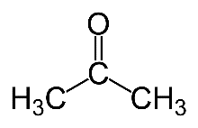
M=15 CH3 fragment  Base Peak=43  Ion CH-CO  1710 cm-1-C=O ketone  2950 cm-1-aliphatic C-H  2.1ppm-6h singlet | 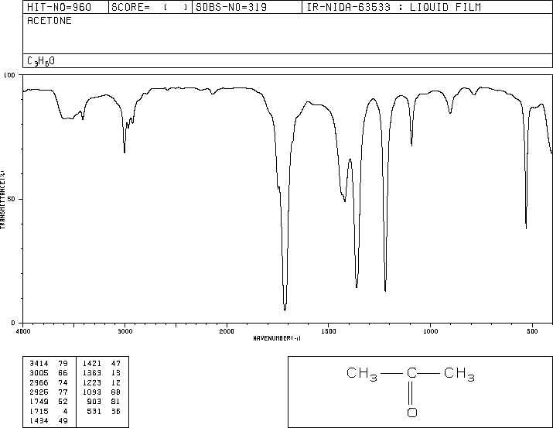

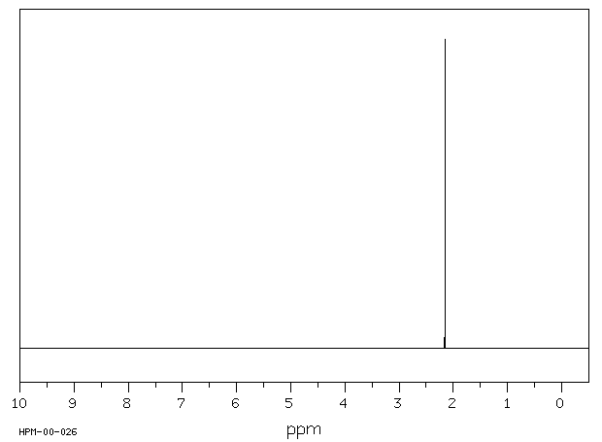 | 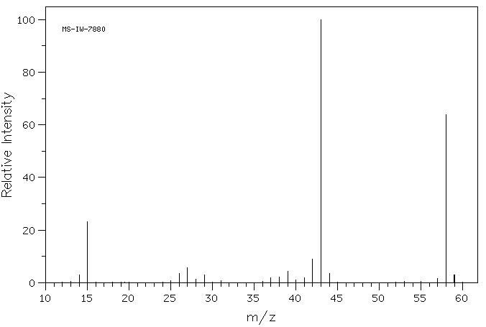

B. | Molecular ion=70  Base peak =29  Fragment- CHO  1705-1710 cm-1-C+O stretch  2700-2800 cm-1-aldehydic C-H  2950 cm-1- aliphatic C-H  1.1ppm-3H triplet,  2.5ppm -2H quartet  9.9 ppm-1H singlet | 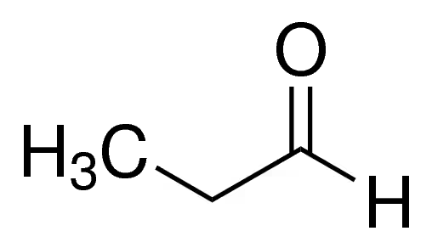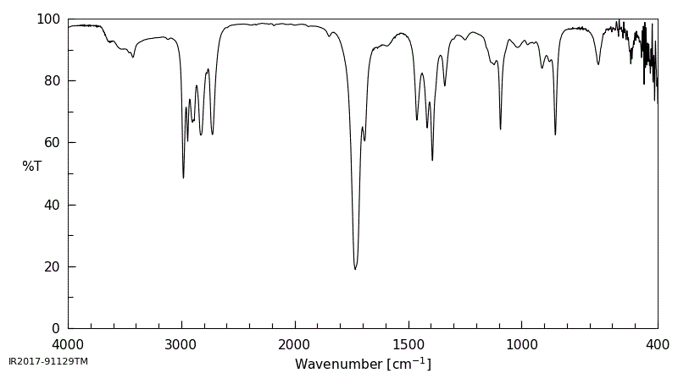

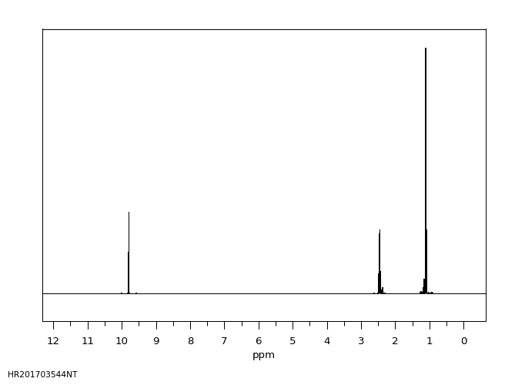 | 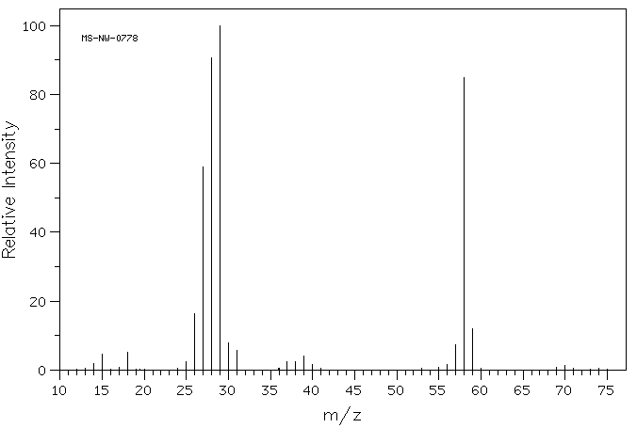

C. | Molecular ion-60  Base peak-43  Fragment COOH  2500-3500cm 1-OH stretch  1700-1650cm-1 C=O stretch  2950cm-1  aliphatic C-H  2ppm-3H single  11.5-1H singlet | 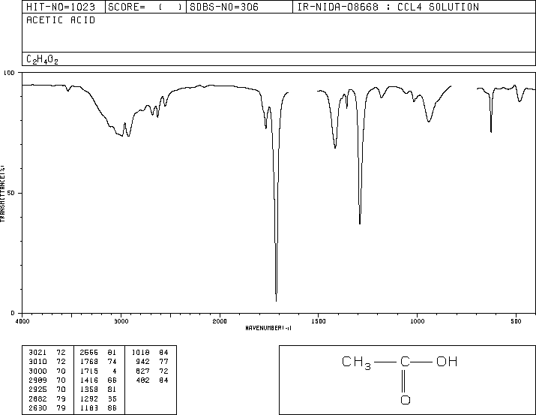

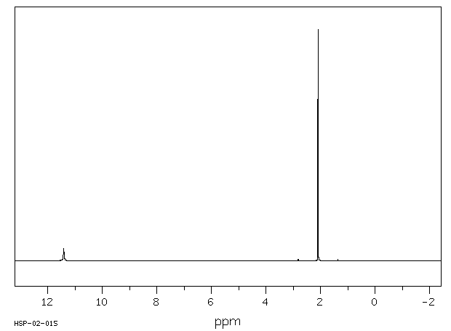 | 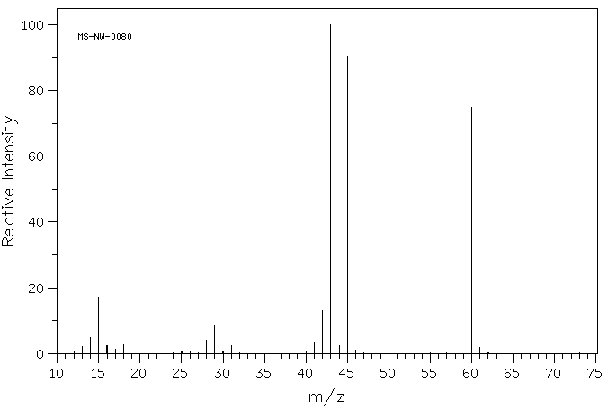

2. Given the molecular formula and the ¹H NMR, IR & MS of the compound, deduce the structure. A. Molecular Formula: $C_{7}H_{8}$.
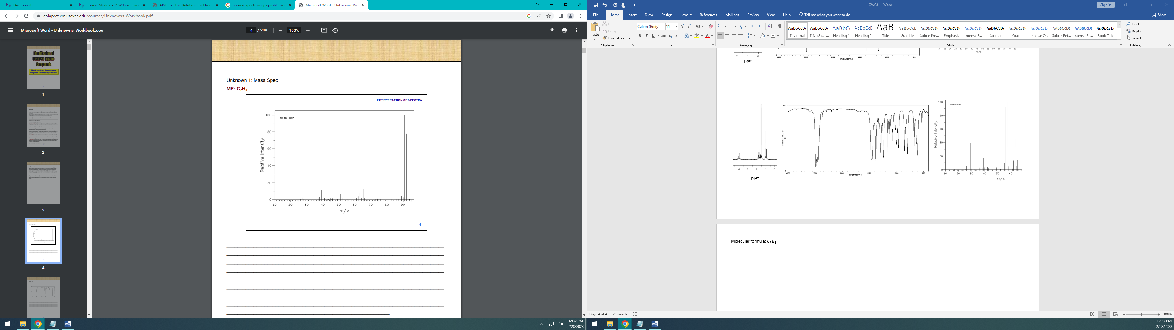 | 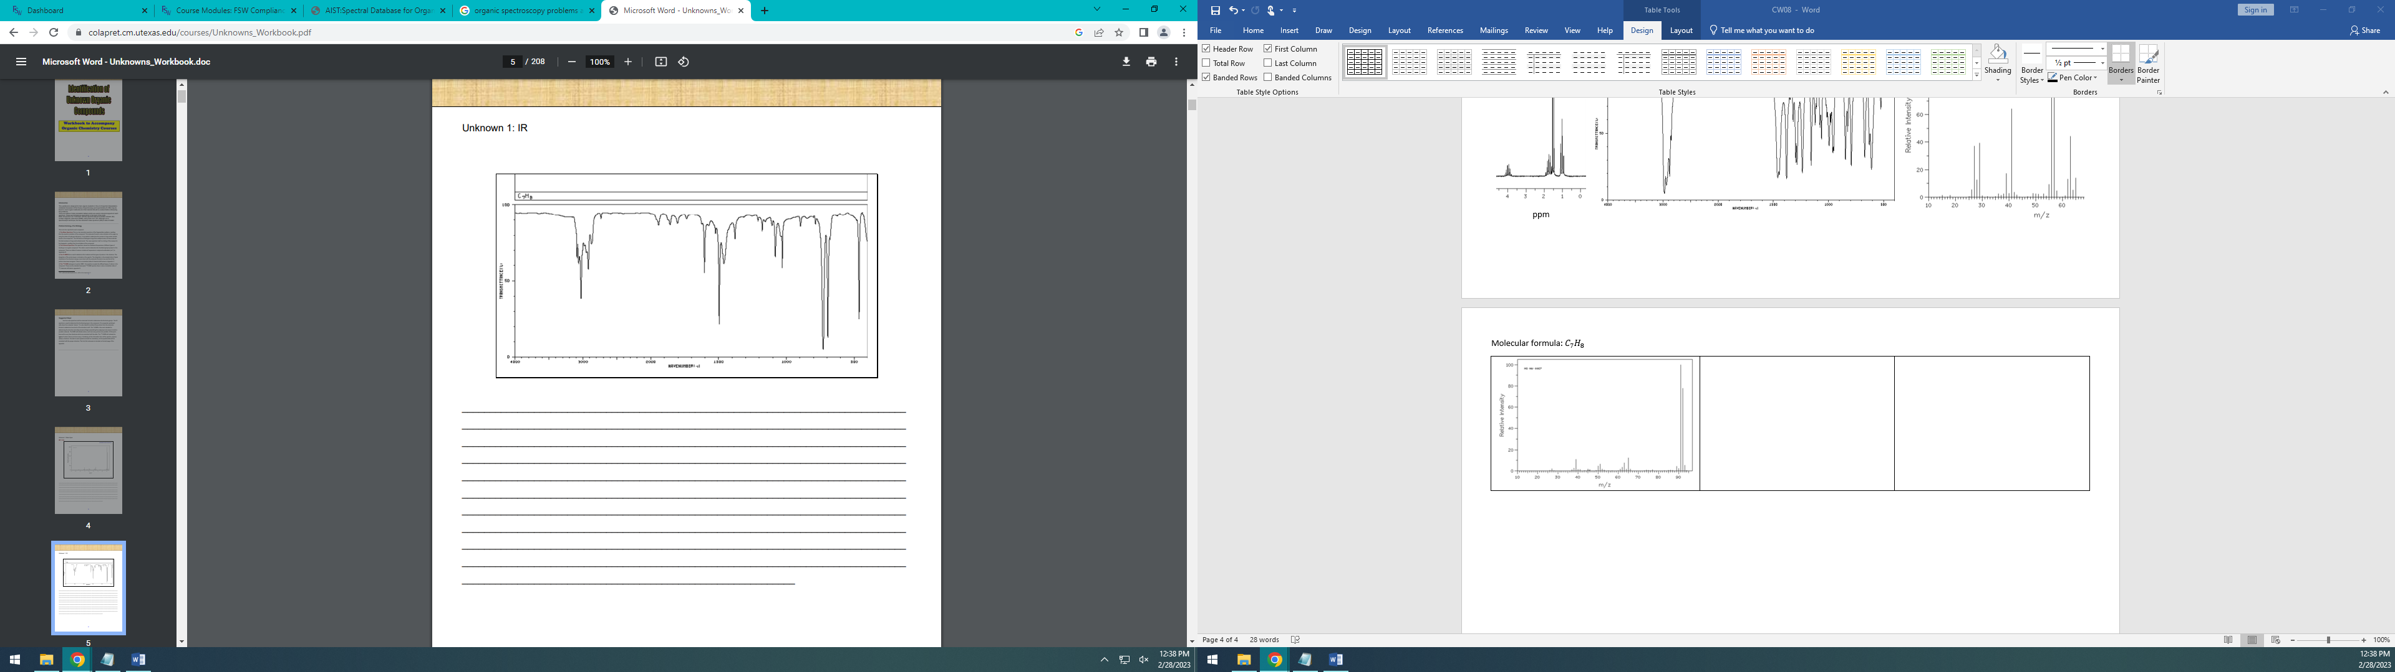
Mass Spectrum | IR Spectrum
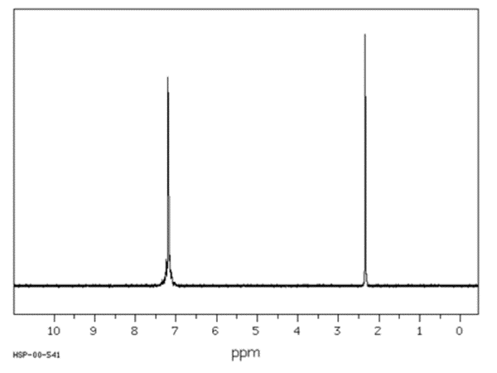 | 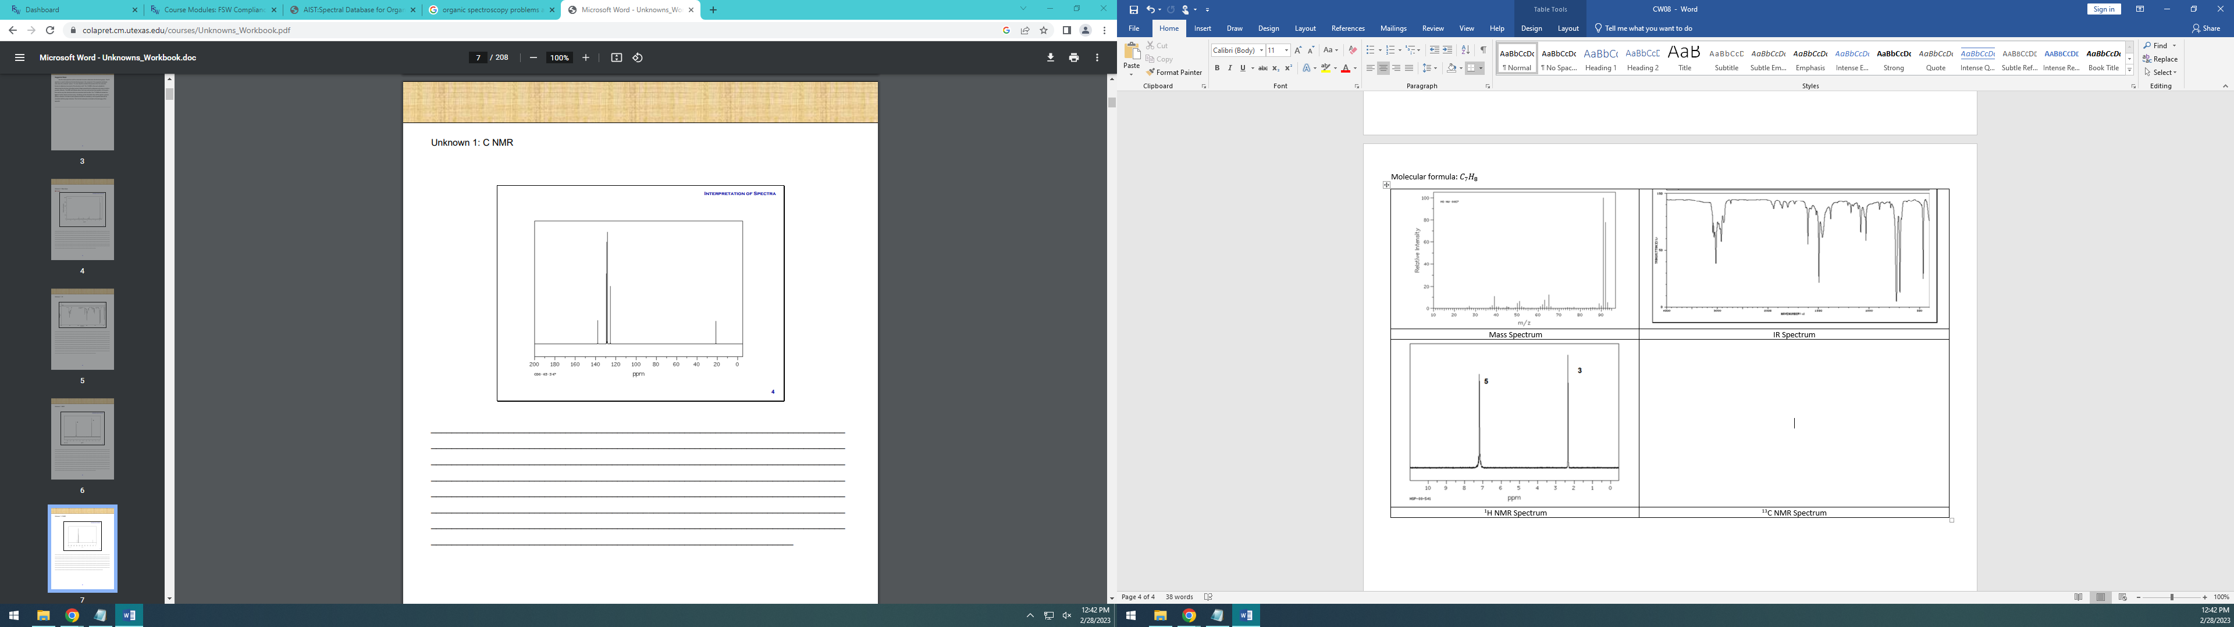
¹H NMR Spectrum | ¹³C NMR Spectrum
B. Molecular Formula: $C_{3}H_{7}Br$
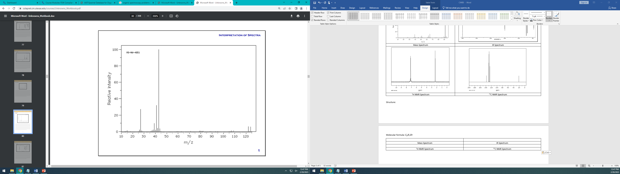 | 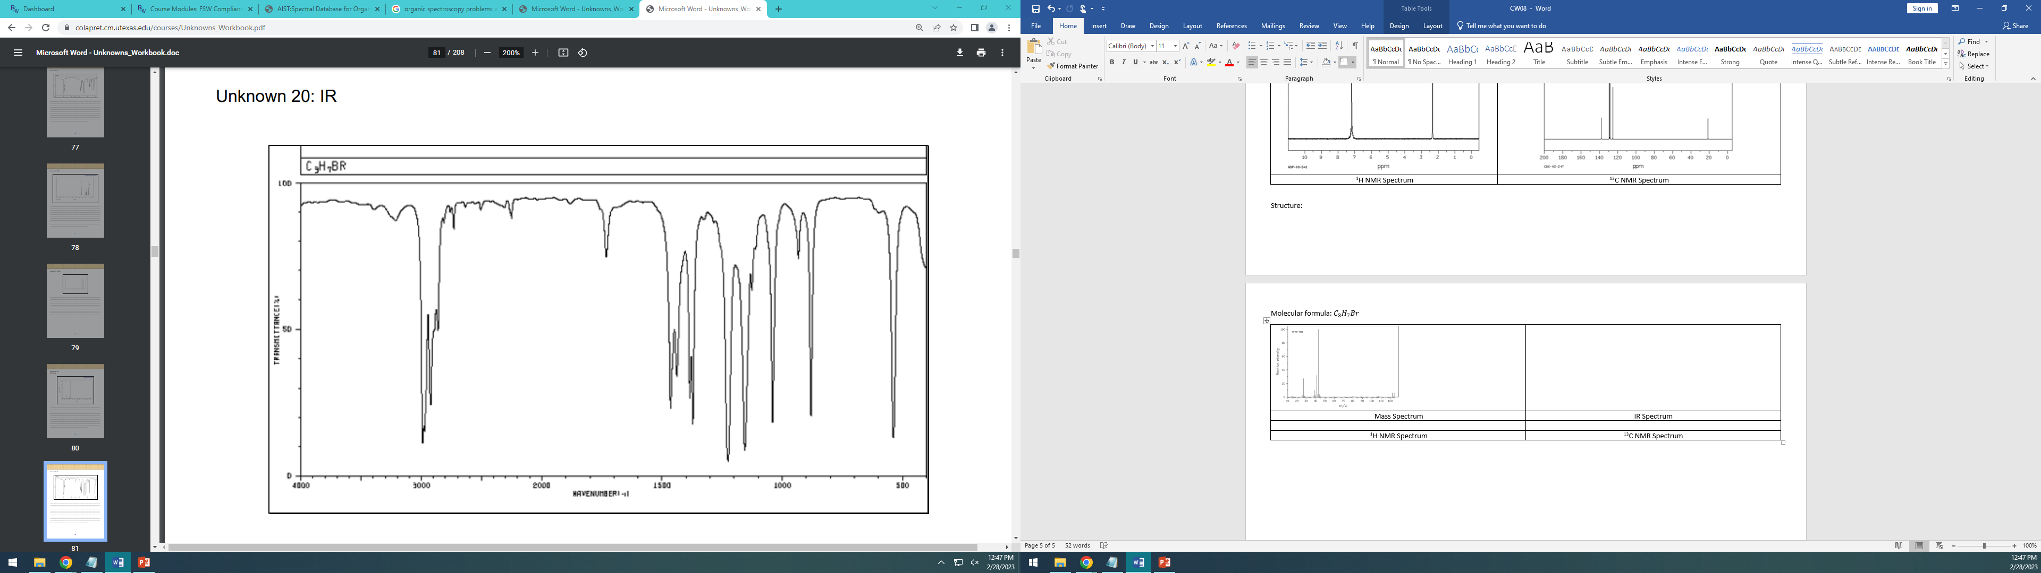
Mass Spectrum | IR Spectrum
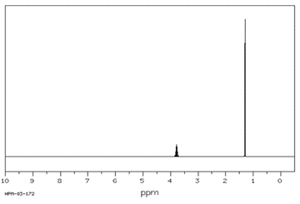 | 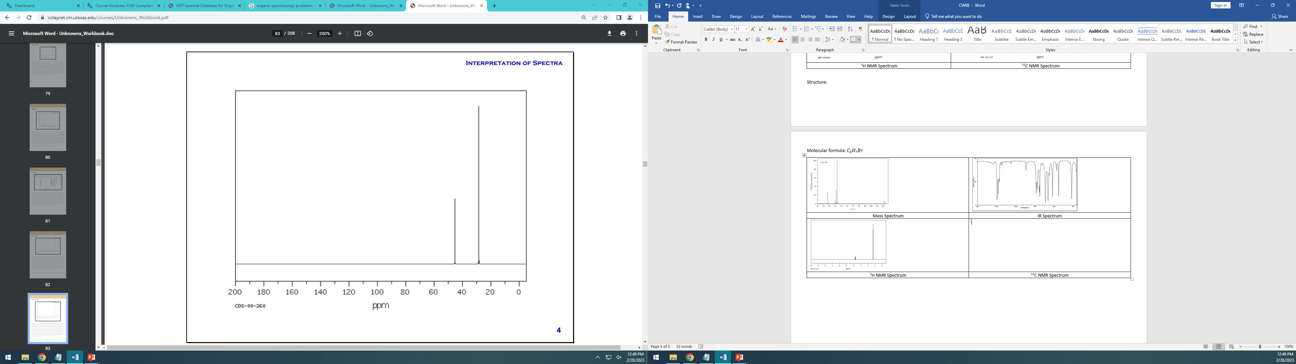
¹H NMR Spectrum | ¹³C NMR Spectrum

